

**Data Visualization**

**Final Project**



**Analysis of High School Academic Performance across Different Districts and Sectors in Israel**

# **Links to dashboards:**

[First Dashboard](https://public.tableau.com/views/OverviewPerformance/OverviewofPerformance?:language=en-US&:display_count=n&:origin=viz_share_link)

[Second Dashboard](https://public.tableau.com/views/DetailedExplorationofSubjects/DetailedExplorationofSubjects?:language=en-US&:display_count=n&:origin=viz_share_link)

Table of Contents

[Links to dashboards: 1](#_Toc141931859)

[Introduction 2](#_Toc141931860)

[Explaining Data 3](#_Toc141931861)

[Ideas and planning: 5](#_Toc141931862)

[Dashboard 1: Overview of Academic Performance 5](#_Toc141931863)

[Dashboard 2: Detailed Exploration of Subjects 7](#_Toc141931864)

[Unapplied idea: 8](#_Toc141931865)

[Our Solution 9](#_Toc141931866)

[Why We Chose This Solution? 9](#_Toc141931867)

[Advantages: 9](#_Toc141931868)

[Disadvantages 10](#_Toc141931869)

[Pre-processing 10](#_Toc141931870)

[Interactions 11](#_Toc141931871)

[Dashboard 1: Overview of Academic Performance 11](#_Toc141931872)

[Dashboard 2: Detailed Exploration of Subjects 18](#_Toc141931873)

[Story: 22](#_Toc141931874)

# **Introduction**

* **T**his project focuses on the examination scores of high school students across different districts and sectors in Israel. Our aim is to explore patterns, trends, and disparities in student performance over the years 2017, 2018, and 2019. The subjects considered are those taught consistently across the three years in the participating schools.
* **O**ur investigation holds significance for educators, school administrators, can benefit from insights that emerge from this analysis, utilizing the findings to influence teaching strategies, academic policies, and resource allocation. Parents and students might find this analysis enlightening, providing them with a more comprehensive picture of the educational landscape across districts and sectors.
* **A**dditionally, this analysis might prove invaluable for education-focused NGOs and governmental organizations, informing them about areas that might require intervention and support. Through our investigation, we seek to not only highlight disparities but also emphasis achievements where they exist.
* **T**he academic performance of students is influenced by various factors such as school type, geographical location, demographic factors, and more.
* **I**n a world where education is often the key to unlocking opportunities, addressing academic disparities is of utmost importance. By illuminating these differences and their potential causes, we hope our project can serve as a stepping stone for more equitable educational policies and practices in Israel.

# **Explaining Data**

* **T**he dataset for our project is distributed across three CSV files, each corresponding to a specific year: 2017, 2018, and 2019. All three files share the same structure, comprising 11 columns each, with a minimum of 14,000 rows in each file.
* The dataset can be accessed through this link: [Bagrut Data](https://www.meida.org.il/11222)
* **T**he dataset is primarily in Hebrew, but to make our data easier to handle and more comprehensible, we translated the column names from Hebrew to English. This was particularly beneficial when defining calculated fields in Tableau. Here are the original column names in Hebrew, along with their corresponding translations and descriptions:
* 'מחוז': 'district', indicating the district in which the school is located.
* 'מגזר': 'sector', representing the demographic sector.
* 'פיקוח': 'school\_type', describing the type of the school (כללי, דתי, עצמאי).
* 'סמל מוסד': 'school\_id', the unique identifier for each school.
* 'שם מוסד': 'school\_name', the name of the school.
* 'ישוב': 'city', the city where the school is located.
* 'מקצוע': 'subject', the specific subject being evaluated.
* 'מחזור סיום': 'class\_of', year.
* 'י"ל': 'units', the number of units for each subject.
* 'מספר נבחנים': 'number\_of\_examinees', the number of students examined in each subject.
* 'ממוצע ציון סופי': 'average\_final\_grade', the average final grade for each subject per school per year.
* **F**urther, to distinguish subjects based on their difficulty levels, we concatenated the 'subject' and 'units' columns, creating a new column called 'subject+units'.
* **A**n additional CSV file was added into our dataset, originally obtained from the Tableau community, containing geocoding information for Israeli cities. This file includes the following columns: 'country', 'state', and 'city'. Originally consisting of 112 rows, the file was modified to align with our data better.
* A new column, 'City HE', was manually added to incorporate the Hebrew city names from our original dataset. This adjustment aids in merging our dataset with the geocoding information and sidesteps any potential mispronunciations. Likewise, we added a 'city EN' column to our original dataset, signifying the city names in English.
* You can access the data through this link: [Israeli Cities Supported by Tableau](https://community.tableau.com/s/question/0D54T00000C6k63SAB/export-of-available-city-names-israel)
* Our modification: [Data after manually mapping cities in Hebrew](https://docs.google.com/spreadsheets/d/1ZXzrZTb30WT6sf3wnQrjI24UblVRkVmTt3sFlp9SKOQ/edit?usp=sharing)
* This integration of the additional geocoding file ensures that our dataset is compatible with geo-spatial analysis in Tableau.

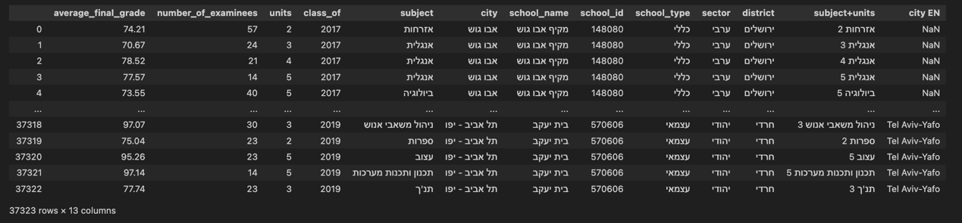

(Number of rows is higher after combining data, it is explained further in [Pre-processing section)](#_Pre-processing" \t "_blank)

# **Ideas and planning:**

## Dashboard 1: Overview of Academic Performance

* Initially, we wanted to investigate the variation in average final grades across various factors present in our data. Specifically, we questioned whether these grades were influenced by different geographical and demographic elements. Thus, we formulated the following research question:
* **Research Question 1: What are the trends and disparities in average final grades across different sectors, districts, and cities over time?**

Given the complexity of the dimensions, it was challenging to represent all in a single graph and get clear graph at the same time. So, we divided it into three sub-questions:

* **Sub Research Question: How have the average final grades changed over the years in each sector?**

Graph: Trends in Average Final Grades by Sector

A line graph seemed to be the most efficient way to illustrate the trend of average final grades in each sector over time, helping to identify improving, declining, or steady sectors.

* **Sub Research Question: How does the average grades vary across different districts in Israel?**

Graph: Average Final Grades by District

With districts in Israel being a core element of this question, the map option in Tableau offered the best visual representation of regional disparities in educational performance.

* **Sub Research Question: What is the average final grade in each city?**

Graph: Average Final Grades by City

A bar chart could have been an option, but given the numerous cities, the graph would be too large. Instead, we used a map to pin each city to its location, allowing for a detailed comparison of performance across cities.

* **Research Question 2: How are schools distributed across different sectors and which ones are performing the best in each sector?**

We split the question into two sub-questions for simplicity:

* **Sub Research Question: What is the distribution of schools across different sectors?**

Graph: Percentage of Schools in Each Sector

This pie (donut) chart helps us understand the representation of each sector in the dataset.

* **Sub Research Question: Which is the top-performing schools in each sector?**

Graph: Top Performing Schools in Each Sector

We employed a bar chart to compare schools within each sector based on their average final grades. Ranking the schools highlighted the highest performers within each sector and revealed performance disparities.

After examining the first five graphs, which explored sector and location-based trends, as well as the top-performing schools in each sector, we decided to delve deeper into multi-sector cities.

* **Research Question 3: How do the average grades of different sectors compare within multi-sector cities?**

Graph: Average Grades Across Multi-Sector Cities

We chose a bar chart for its interpretability and visual appeal. The goal was to understand if performance variations were as pronounced when comparing sectors within the same city. This could highlight disparities and offer insight into whether location plays a role in performance.

## Dashboard 2: Detailed Exploration of Subjects

For this dashboard, we were interested in understanding the trends in subject performance and how subject distribution varies by sector.

* **Research Question 4: Which subjects have shown the most significant improvement or decline from 2017 to 2019?**

Graph 2 & 3: Top/Bottom Performers Subjects by Score Percentage Improvement from 2017 till 2019

To visualize this, we used bar graphs, which effectively highlight the subjects that have shown the most and least progress over the specified period. This can help identify subjects that may require additional attention due to a drop in the average, or subjects that have demonstrated remarkable improvements.

* **Research Question 5: What are the most taught subjects in each sector?**

Graph: Most Common Subjects by Sector

We employed a stacked bar chart for this visualization due to its capability to clearly show the relative distribution of subjects taught across different sectors. This chart illustrates the popularity of subjects within each sector, offering insights into educational priorities or interests in different sectors.

After identifying the most common subjects, we sought to investigate the performance in what we call 'core' or 'essential' subjects – those that are needed to earn the Bagrut certificate. We referred to the Ministry of Education's requirements to establish a set of these core subjects, keeping in mind that they can vary from one sector to another.

* **Research Question 6: How do average grades for core subjects compare across sectors?**

Graph: Grade Comparison of Essential Subjects Across Sectors

We opted for a circle view graph where each sector is represented by a color in the subject column. This format allows for an effective comparison of academic performance in key subjects across different sectors, thereby highlighting disparities and potential areas for focus in each sector.

## Unapplied idea:

* One important dimension we wished to explore was the percentage of students in each school or sector who were eligible to earn their Bagrut certificate (זכאות לתעודת בגרות) in accordance with the regulations set by the Ministry of Education. This analysis could have given us deeper insights into the overall academic success rate in different schools and sectors and could have highlighted areas where interventions might be needed to increase Bagrut eligibility rates. Unfortunately, we were unable to implement this idea because we did not have access to data on the total number of students who graduated high school in each school.

# **Our Solution**

* Our solution revolved around creating two dashboards: 'Overview of Performance' and 'Detailed Exploration of Subjects'. The former focuses on assessing the variation in average final grades across different factors, including sector, district, and city. The latter focuses on the trends in subject performance and their distribution across different sectors. We believed that such a dichotomy would allow for a comprehensive yet digestible analysis of academic performance across Israel.

## Why We Chose This Solution?

* Our decision to focus on these specific dashboards was primarily driven by the desire to provide a comprehensive understanding of academic performance in Israel. By dividing the complex data into distinct but interrelated research questions, we were able to offer in-depth insights into different aspects of academic performance, such as geographical and sector-based trends, subject-specific performance, and improvements or declines over time.

## Advantages:

* The strength of our solution lies in its ability to reveal nuanced trends and disparities in a visually engaging and understandable way. The chosen visualizations provide an easy-to-digest representation of the data, facilitating comparisons and highlighting trends and anomalies. For instance, the map visualization, despite its limitations, gives a direct, visually intuitive representation of regional differences in academic performance. Similarly, the line and bar graphs allow for clear comparisons over time or across sectors and subjects.
* Additionally, we designed our dashboards to be adjustable based on user preference. The "Top/Bottom Performers Subjects by Score Percentage Improvement" graphs, for instance, can be adjusted to show the top 10, top 20, or any other range the user wishes to explore. This dynamic feature allows users to interact with the data and customize their view, enhancing their understanding and engagement with the data.

## Disadvantages

* One of the challenges was the incomplete geolocation support in the Tableau map of Israel. This resulted in some cities potentially being missed from our geographical analysis.
* Moreover, while our approach to dividing the data into distinct research questions provides depth, it also presents a potential user challenge. The viewer might need to navigate through several graphs or dashboards to make connections between different data aspects, such as comparing academic performance across cities, sectors, and subjects. This might make the data less accessible for those preferring a more holistic view.
* Finally, another limitation is related to the geographical display of the data. While the map visualization provides a clear depiction of regional disparities, it could be time-consuming for users to find a specific city if they are unfamiliar with Israel's geography.

# **Pre-processing**

* In preparation for our analyses, we cleaned and pre-processed the data.
* First, we kept only schools that were present in all three years of our dataset, to ensure that our year-over-year comparisons were accurate and meaningful. Furthermore, for each of these schools, we kept only those subjects that were taught consistently over the three-year period. This decision aligns with our project's goal of comparing and analyzing disparities in data across multiple sectors/districts, and it eliminates potential inconsistencies and null values resulting from newly introduced or discontinued subjects.
* We stripped unnecessary spaces from the dataset, thereby ensuring that every data point was consistently formatted.
* The individual datasets for each year were then concatenated into a single file.
* Our data contains:
* 305 villages and cities.
* 928 unique schools.
* 115 unique subjects.
* 3 types of school (פיקוח): ['כללי', 'דתי', 'עצמאי'].
* 4 sectors: ['ערבי', 'יהודי', 'בדואי', 'דרוזי'].
* 9 districts: (['ירושלים', 'דרום', 'תל אביב', 'מרכז', 'חיפה', 'צפון','חינוך התישבותי', "מנח'י", 'חרדי']).
* In Tableau, we noticed that the 'School Type' field was more relevant to the Jewish sector. Each school type within this sector differed significantly from the others. Consequently, we decided to differentiate further within the Jewish sector using a calculated field that combines 'Sector' and 'School Type'. This enabled us to create more nuanced categories, leading to the following sectors: ['ערבי', 'יהודי', 'בדואי', 'דרוזי', 'יהודי דתי', 'יהודי חרדי']. This breakdown allows for a more granular analysis of academic performance across various Jewish sub-sectors.

# **Interactions**

## [Dashboard 1: Overview of Academic Performance](https://public.tableau.com/app/profile/malak.yehia8824/viz/OverviewPerformance/OverviewofPerformance)

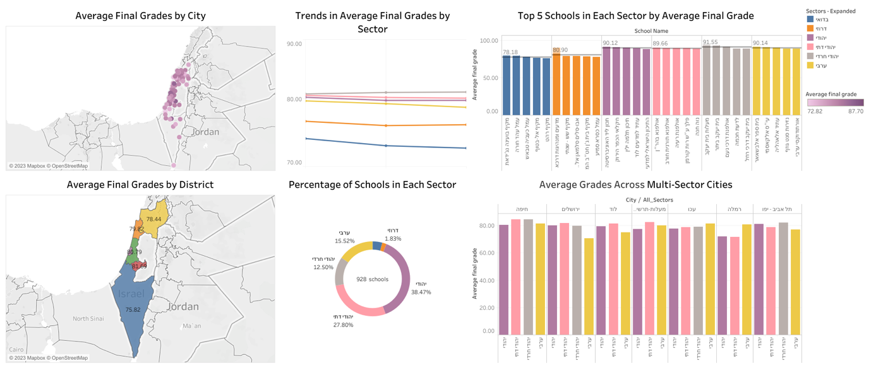

* Graph: Trends in Average Final Grades by Sector

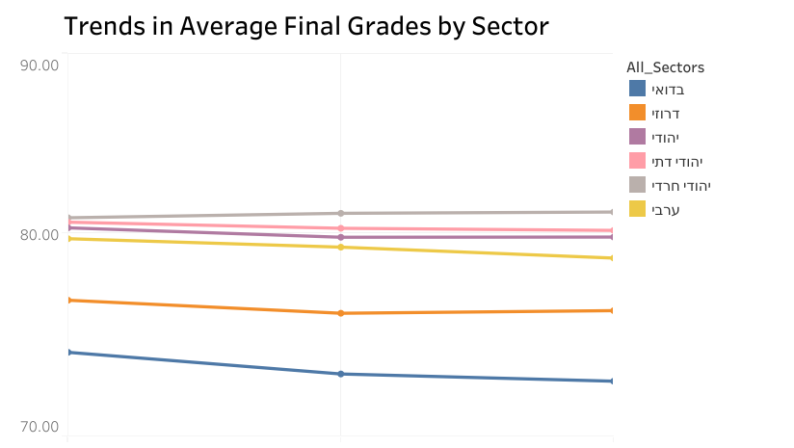

**Interaction:** The line graph enables users to view the average final grades for each sector in the years 2019, 2018, and 2017. Users can hover over the data points in the line graph to access detailed information, including the sector, year, and corresponding average final grade.

**Task:** The visualization captures changes in average final grades among different sectors over time. Users can observe trends and identify sectors that have improved, declined, or remained relatively stable in their academic performance.

**Mapping:** The chart maps the year to the x-axis and the average final grades to the y-axis. Each data point on the line corresponds to a specific year, and the color denotes the sector.

[Graph Link](https://public.tableau.com/app/profile/malak.yehia8824/viz/TrendsinAverageFinalGradesbySector/TrendsinAverageFinalGradesbySector)

* **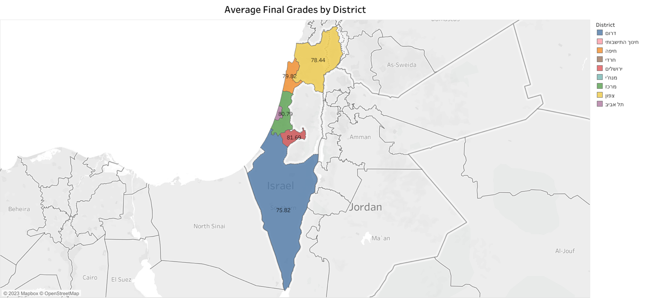**Graph: Average Final Grades by District

**Interaction:** The map graph lets you see and hover over the different districts of Israel. When you hover over a district, you can see details like the sector, average grade of the district, and number of schools in that district.

**Task:** With this map, you can compare the average final grades across districts and examine the differences and disparities between them.

**Mapping:** The map shows the districts and their average final scores. Each district is represented by a different color, making it easy to see and compare the performance of students in various areas.

The label on each district is the average grade of all schools in that district (zoom in is needed to view label in some districts).

[Graph Link](https://public.tableau.com/app/profile/malak.yehia8824/viz/AverageFinalGradesbyDistrict/GeographicDistributionofSchoolPerformancebyDistrictinIsrael)

* Graph: Average Final Grades by City

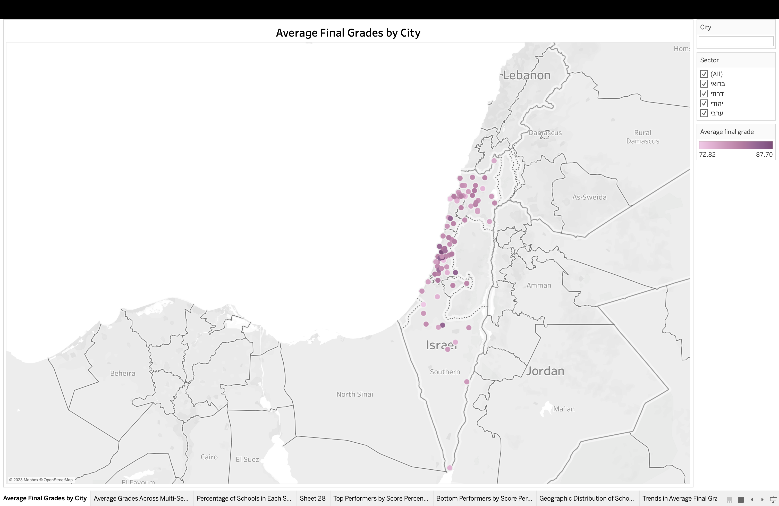

**Interaction:** The interactive map allows you to explore and click on various cities in Israel. When you hover over a city, it displays important details such as the city name and the average grade of its students. User who wish to view specific city can do so by typing in the search box (in Hebrew), the user can also filter by sector.

**Task:** Use this map to compare the average final grades among different cities in Israel and understand how academic performance varies within geographic locations. It helps you make comparisons between the academic achievements of cities.

**Mapping:** The map uses gradient palette to indicate average final grades of each city. Darker colors indicate higher grades, and lighter colors indicate lower grades, making it simple to visually compare city performance.

[Graph Link](https://public.tableau.com/app/profile/malak.yehia8824/viz/AverageFinalGradesbyCity/AverageFinalGradesbyCity)

* Graph: Percentage of Schools in Each Sector

**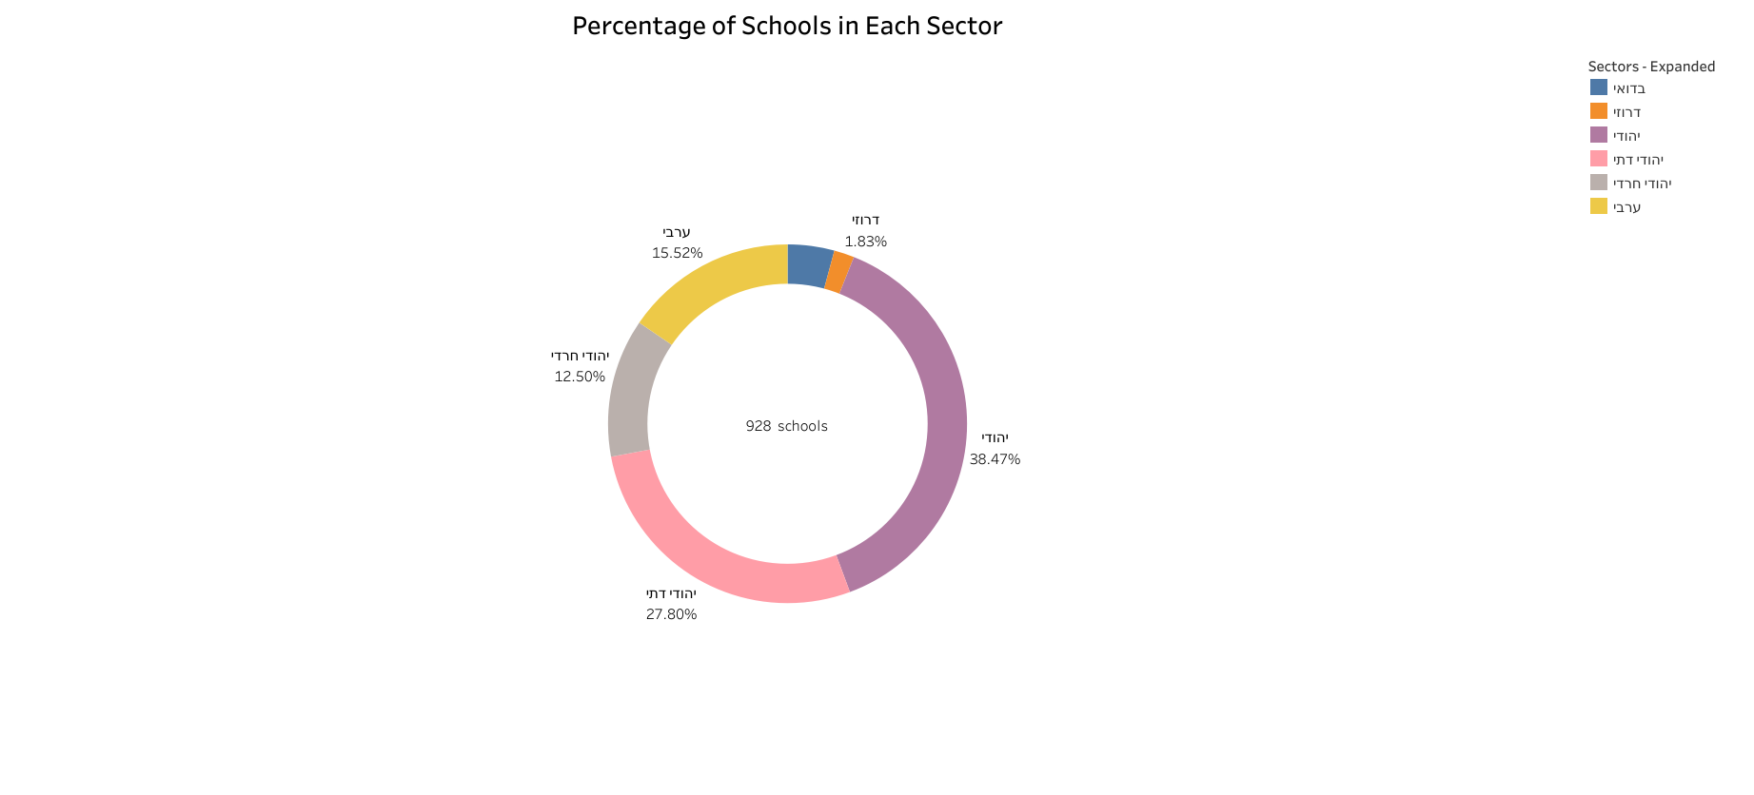**

**Interaction:** The pie (doughnut) chart allows users to hover over each sector to view the number of schools in that sector, as well as the proportion of this number out of the total number of schools.

**Task:** Use this pie chart to understand the distribution of schools across different sectors.

**Mapping:** The chart’s segment sizes represent the proportion of each sector’s number of schools out of the total number of schools in all sectors. Colors denote the sectors.

[Graph Link](https://public.tableau.com/app/profile/malak.yehia8824/viz/PercentageofSchoolsinEachSector/PercentageofSchoolsinEachSector)

* 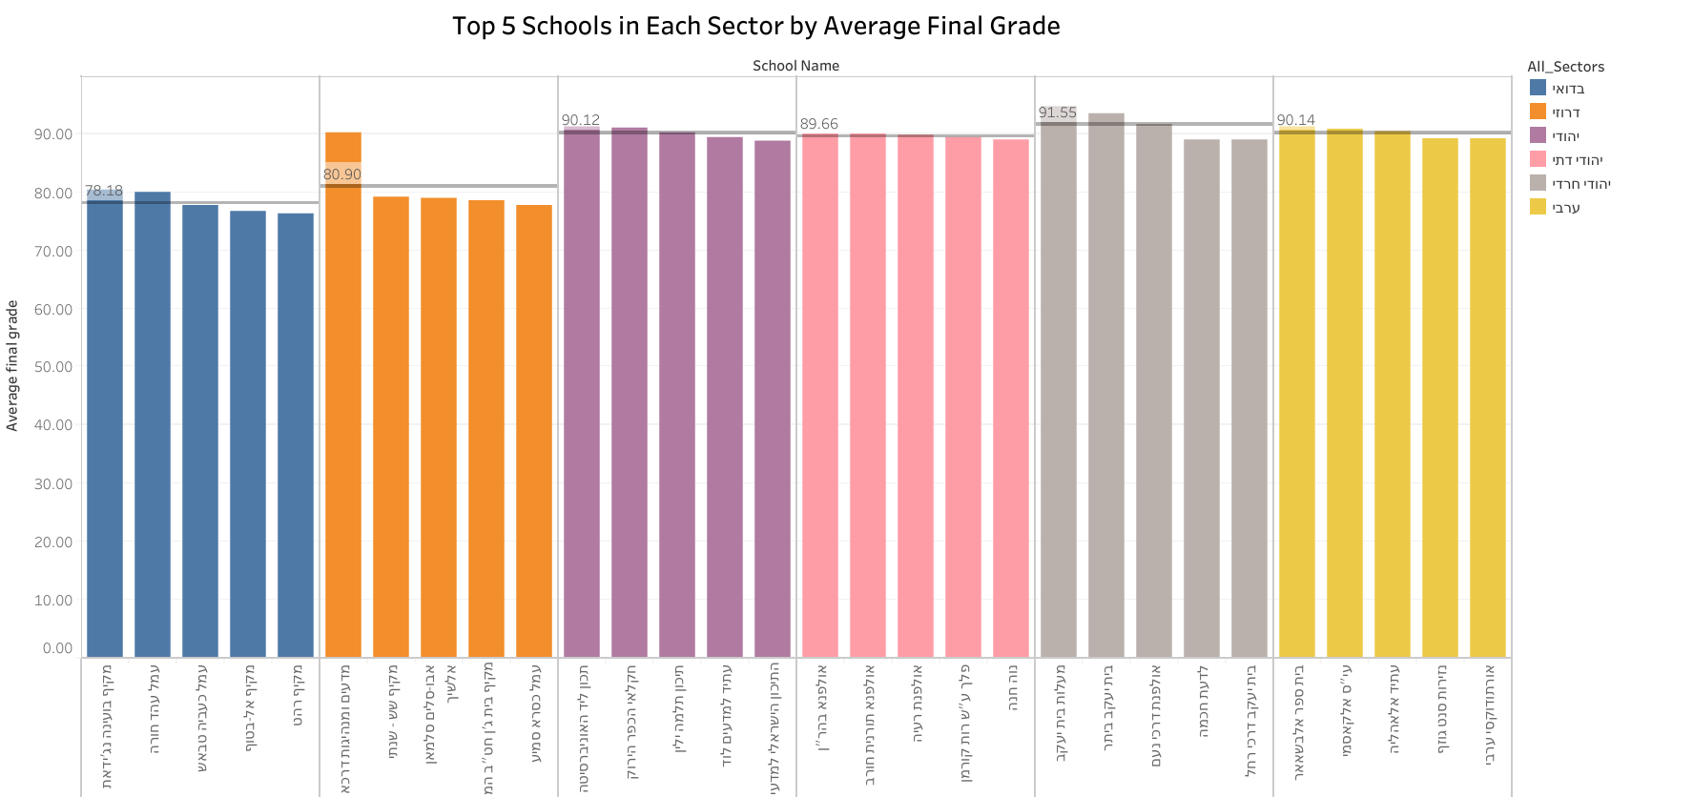Graph: Top 5 Schools in Each Sector by Average Final Grade

**Interaction:** The bar chart provides an interactive experience where users can hover over each bar to view detailed information about the school, such as its sector, name, city, district, and the average final grade of the school. Users can also click on a specific bar representing a school, and the chart will focus on that school's performance, allowing for a more in-depth analysis.

**Task:** The bar chart's main purpose is to compare the top performing schools in each sector and compare how “best performance” definition vary from one sector to the other.

**Mapping:** Average final grades on the y-axis, while school names are listed on the x-axis, with grouping sectors together on the chart. Each sector is represented by a unique color, simplifying the comparison of performance across sectors. Additionally, a horizontal line signifies the overall average of the top 5 schools.

[Graph Link](https://public.tableau.com/app/profile/malak.yehia8824/viz/Top5SchoolsinEachSectorbyAverageFinalGrade/Top5SchoolsinEachSectorbyAverageFinalGrade)

* **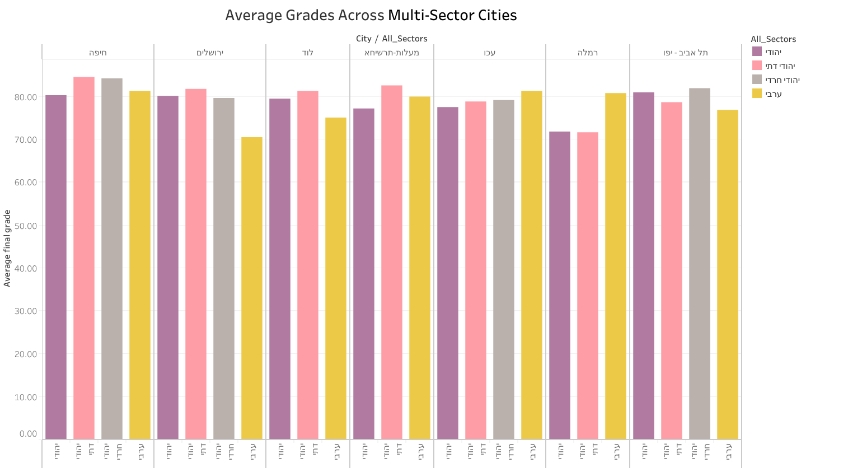**Graph: Average Grades Across Multi-Sector Cities

**Interaction:** The bar chart is interactive, letting users hover over each bar to see details about a sector in a specific city. They can view the city name, sector, number of schools within this city’s sector and the average grades for that sector.

**Task:** The chart compares performance among different sectors within same city. It helps identify performance gaps within the same city, and highlighting disparities. This also helps understand the impact of location on academic performance.

**Mapping:** The chart visually displays average final grades on the y-axis, while the x-axis represents the sectors grouped by city. Each sector is shown in a distinct color.

Note: we didn’t consider cities that have multiple types of Jewish schools as multi-sector cities.

[Graph Link](https://public.tableau.com/app/profile/malak.yehia8824/viz/AverageGradesAcrossMulti-SectorCities/AverageGradesAcrossMulti-SectorCities)

## [Dashboard 2: Detailed Exploration of Subjects](https://public.tableau.com/views/DetailedExplorationofSubjects/DetailedExplorationofSubjects?:language=en-US&:display_count=n&:origin=viz_share_link)

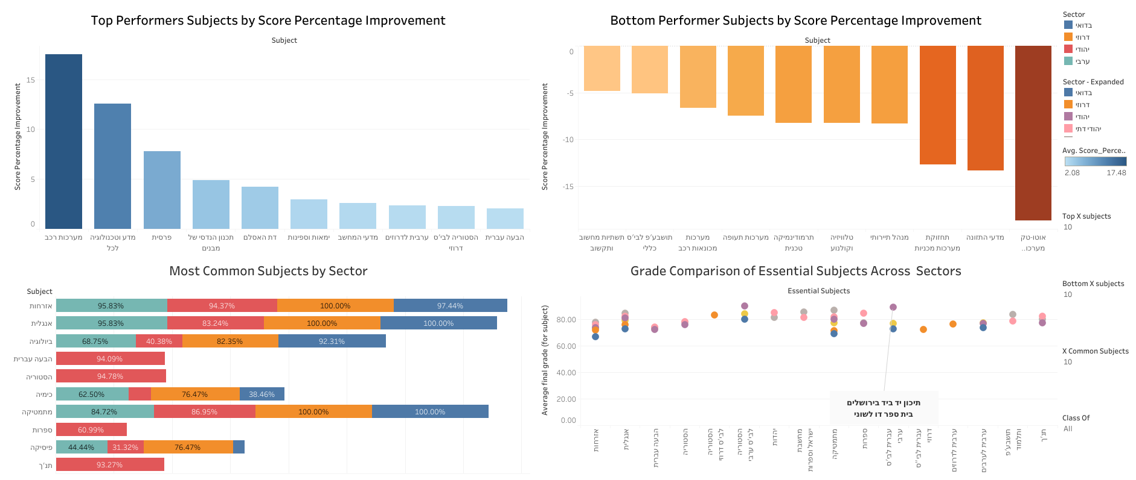

* Graph: Top/Bottom Performers Subjects by Score Percentage Improvement from 2017 till 2019

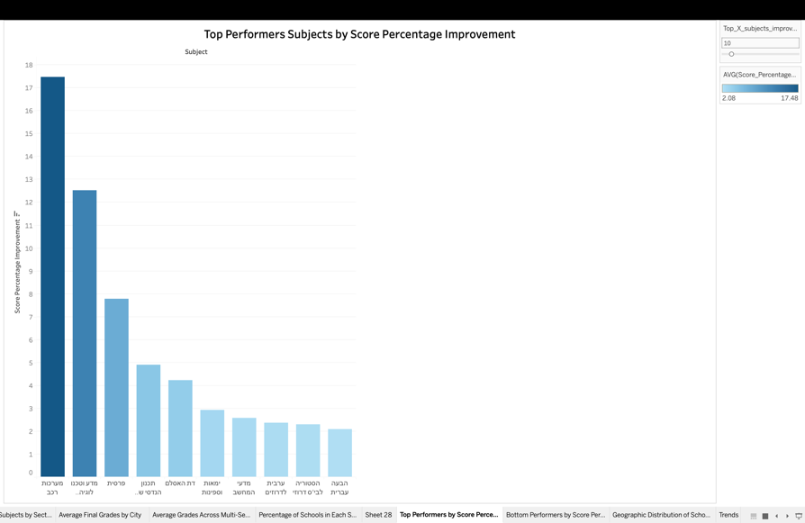

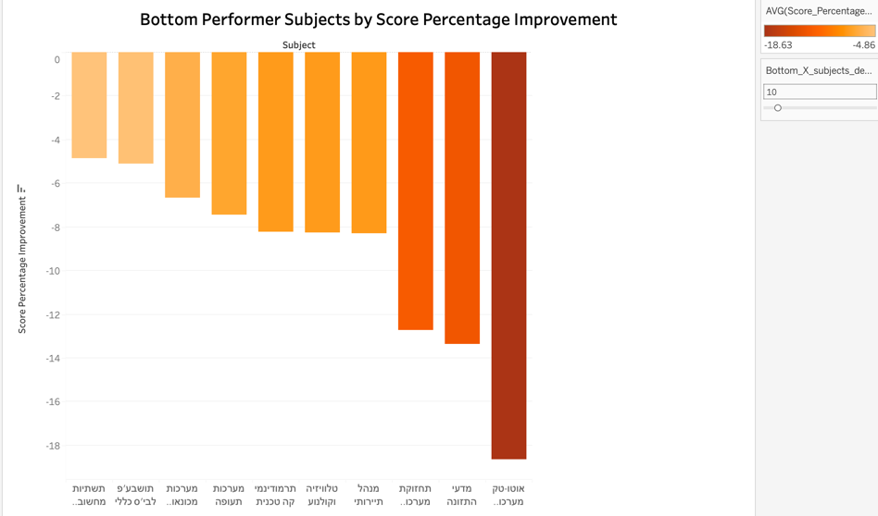

**Interactivity:** The bar charts are interactive, allowing users to hover over each bar and view details about the average scores for different subjects in 2017 and 2019, along with the percentage that shows whether this subject showed an improvement or not. Number of subjects that can be shown could be adjusted with a slider that we provided (when maximizing number of viewed subjects, we get identical graphs, but we did separate graphs to view both info (most/least progress) at the same time).

**Task:** The chart helps identifying which topics showed the most and least progress from 2017 to 2019. This information can be used to focus on subjects that need more attention or support due to the drop.

**Mapping:** The bar chart displays the progress percentage on the y-axis and the subjects on the x-axis. Gradient palette is used to highlight most/least progress.

In both graphs, multiple calculated fields were created from the data to visualize this task.

[Graph Link Top Performers](https://public.tableau.com/app/profile/malak.yehia8824/viz/TopPerformersSubjectsbyScorePercentageImprovement/TopPerformersbyScorePercentageImprovement)

[Graph Link Bottom Performers](https://public.tableau.com/app/profile/malak.yehia8824/viz/BottomPerformerSubjectsbyScorePercentageImprovement/BottomPerformersbyScorePercentageImprovement)

* Graph: Most Common Subjects by Sector

**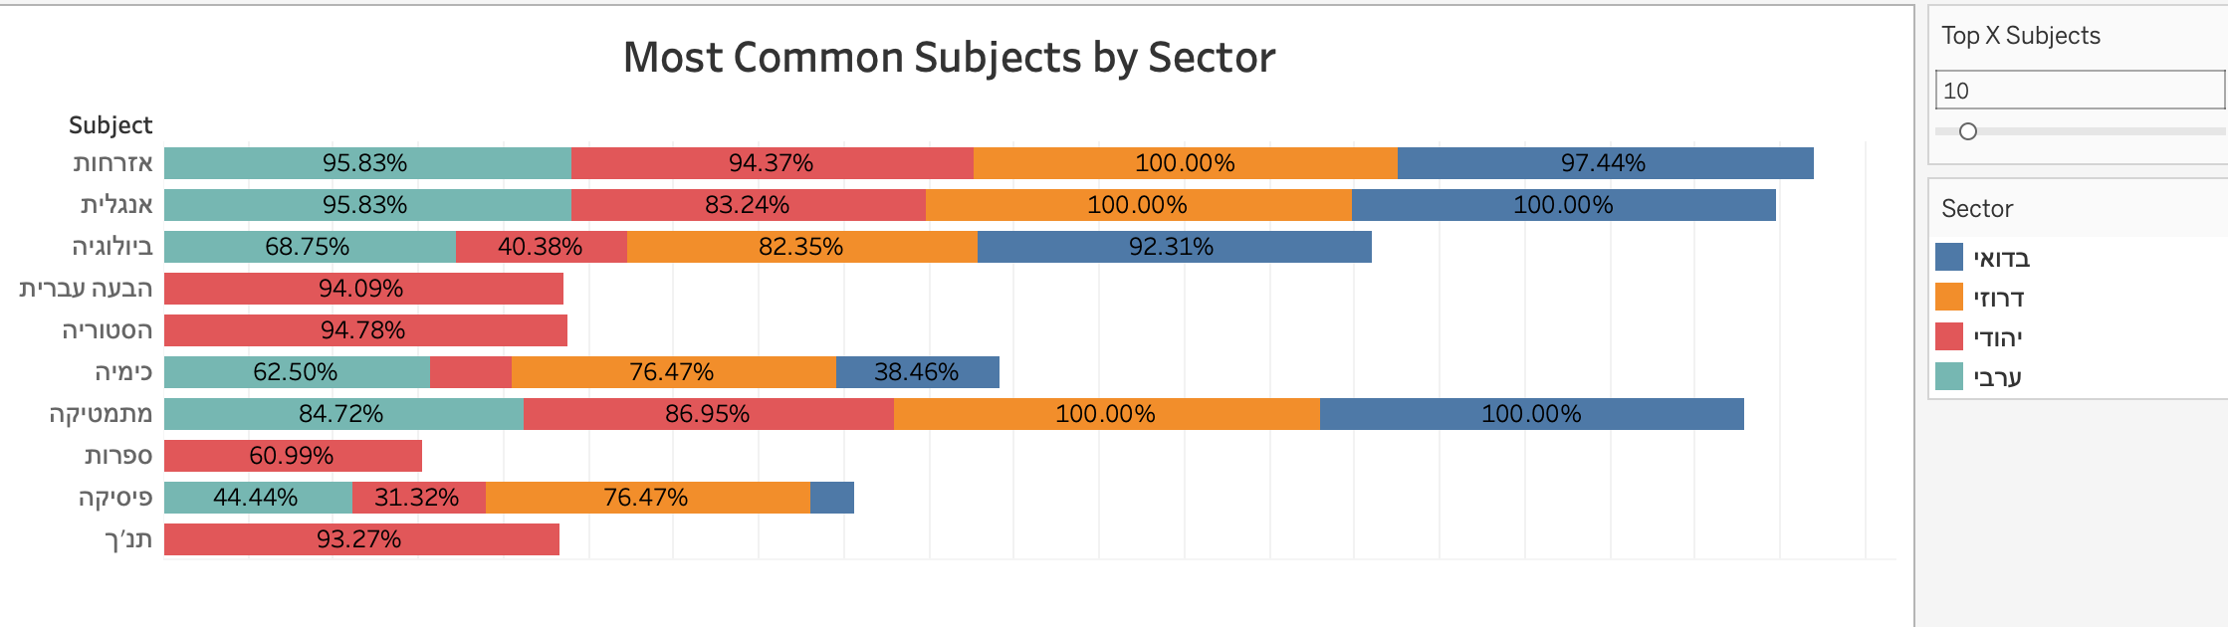**

**Interactivity:** The stacked bar chart is interactive. Users can hover over each segment to see details about the subject and the percentage of schools teaching that subject within the sector. The number of viewed subjects can be modified via the provided slider.

**Task:** The chart shows which topics are most common in each sector. It provides insights into educational priorities and interests within different sectors.

**Mapping:** The stacked bar chart displays subjects on y-axis, with each sector shown in a different color. The length of each segment represents the percentage of schools teaching that subject in a specific sector, making it easy to compare subject popularity across sectors.

Percentages and info were created via calculated fields.

[Graph Link](https://public.tableau.com/app/profile/malak.yehia8824/viz/MostCommonSubjectsbySector/LeastCommonSubjectsbySector)

* Graph: Grade Comparison of Essential Subjects Across Sectors

**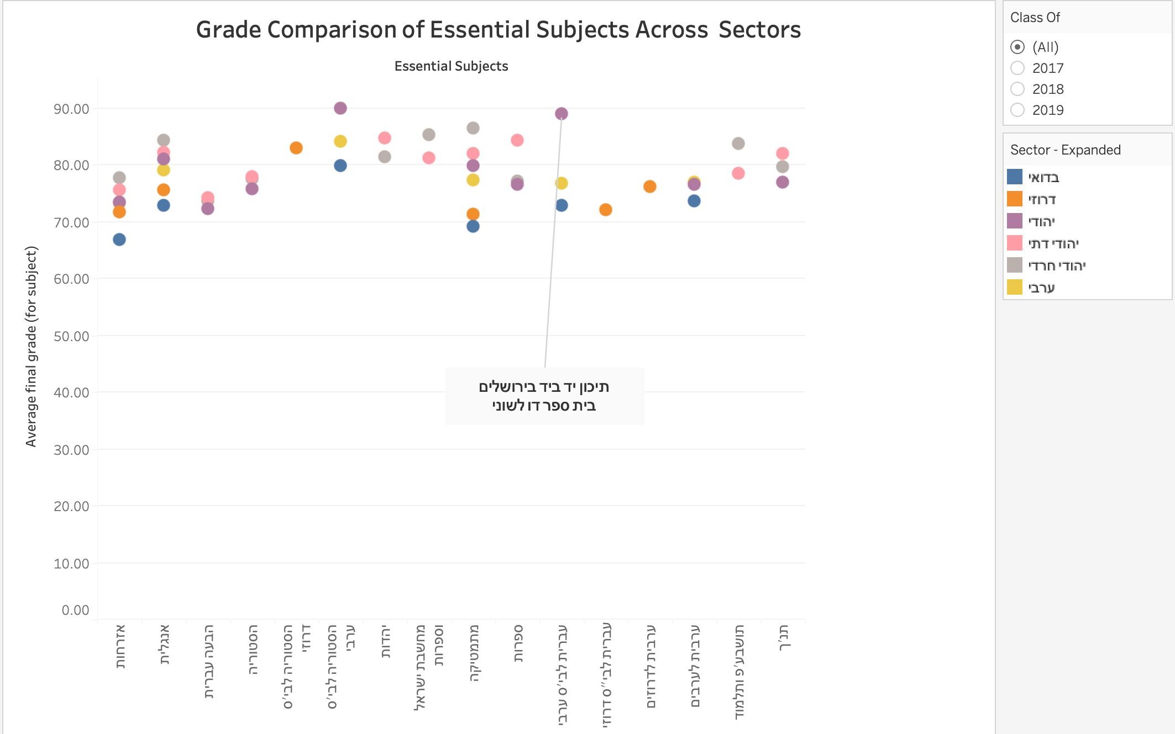**

**Interactivity:** The circle view graph is interactive. Users can hover over any point representing a sector to see the average score for each core subject in that sector. They can also filter the information to display scores average for a specific year (2017, 2018, or 2019) or the overall average for all years.

**Task:** The graph allows users to compare academic performance in key subjects across different sectors. It highlights gaps and areas for improvement in each sector, making it easy to identify sectors that excel or need support in specific core subjects.

**Mapping:** The circle view graph displays the average final scores on the y-axis and the core subjects on the x-axis. Sectors are colored.

Note: we observed dots that belongs to the Jewish sector under subjects that are taught in Arab/Druze/Bedouin sectors only, so we checked it and found that these dots belong to one school only and it is called [“תיכון יד ביד”](https://www.hih.org.il/area/jerusalem_school/), which is multi language school in Jerusalem.

[Graph Link](https://public.tableau.com/app/profile/malak.yehia8824/viz/GradeComparisonofEssentialSubjectsAcrossSectors/GradeComparisonofEssentialSubjectsAcrossSectors)

## **Story:**

[Link to story](https://public.tableau.com/views/UnlockingtheProgressADeepDiveinto5UnitsofEnglishinIsrael/Story1?:language=en-US&:display_count=n&:origin=viz_share_link)

For our story, we focused on a specific subject which is English, and specifically 5 units of English.

The story features 4 graphs:

The graph shows number of schools offering 5 units of English over the years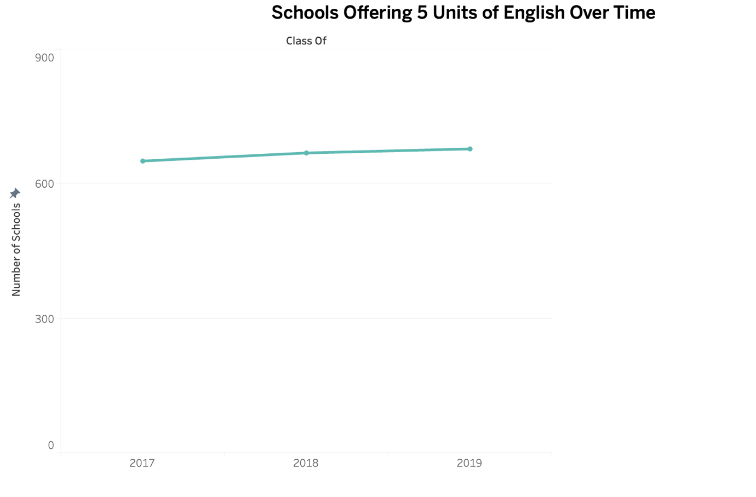.

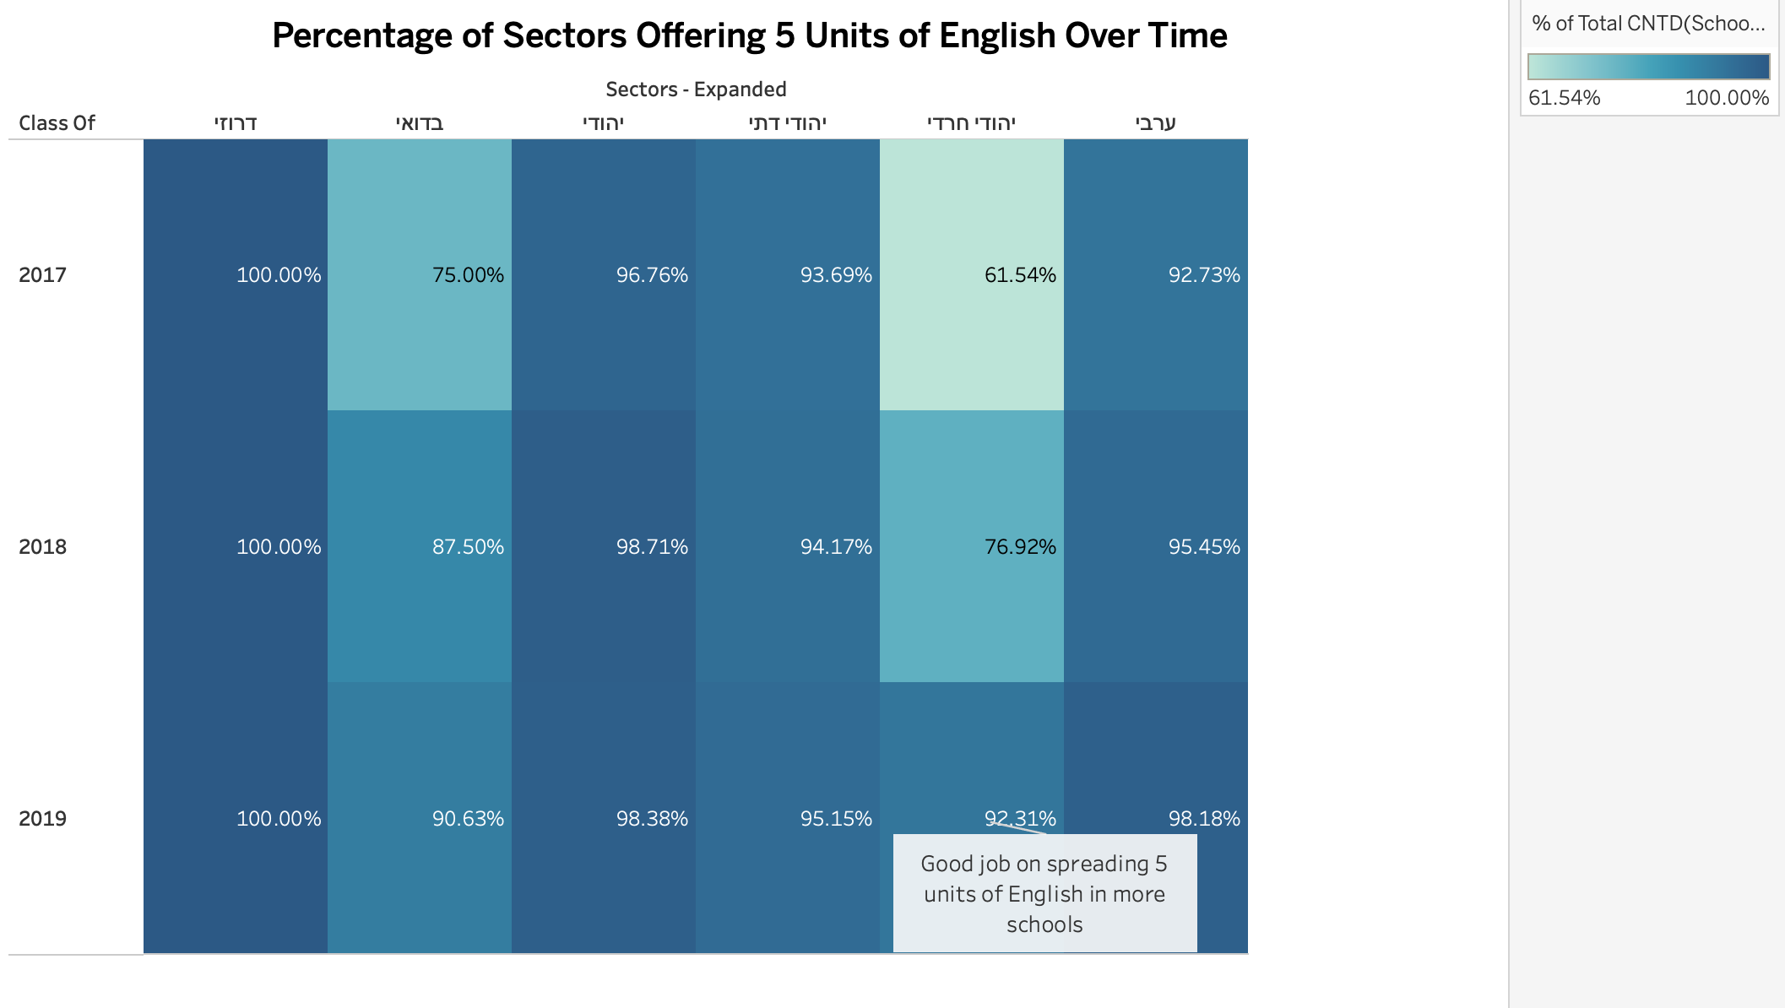

The graph shows the number of schools offering 5 units of English across sectors.

We can observe a significant increase in “חרדי” sector (we inserted an annotation, but tableau wouldn’t let us place it outside the graph).

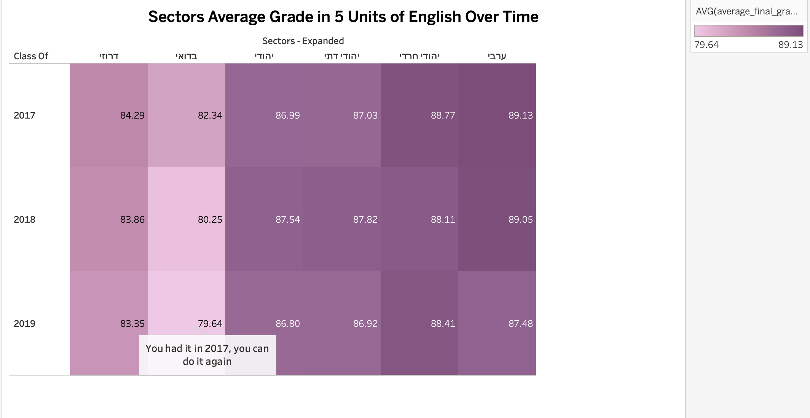

The graph shows average grade of 5 units of English by sector. We can observe that there’s a drop in the performance among the Bedouin sector.

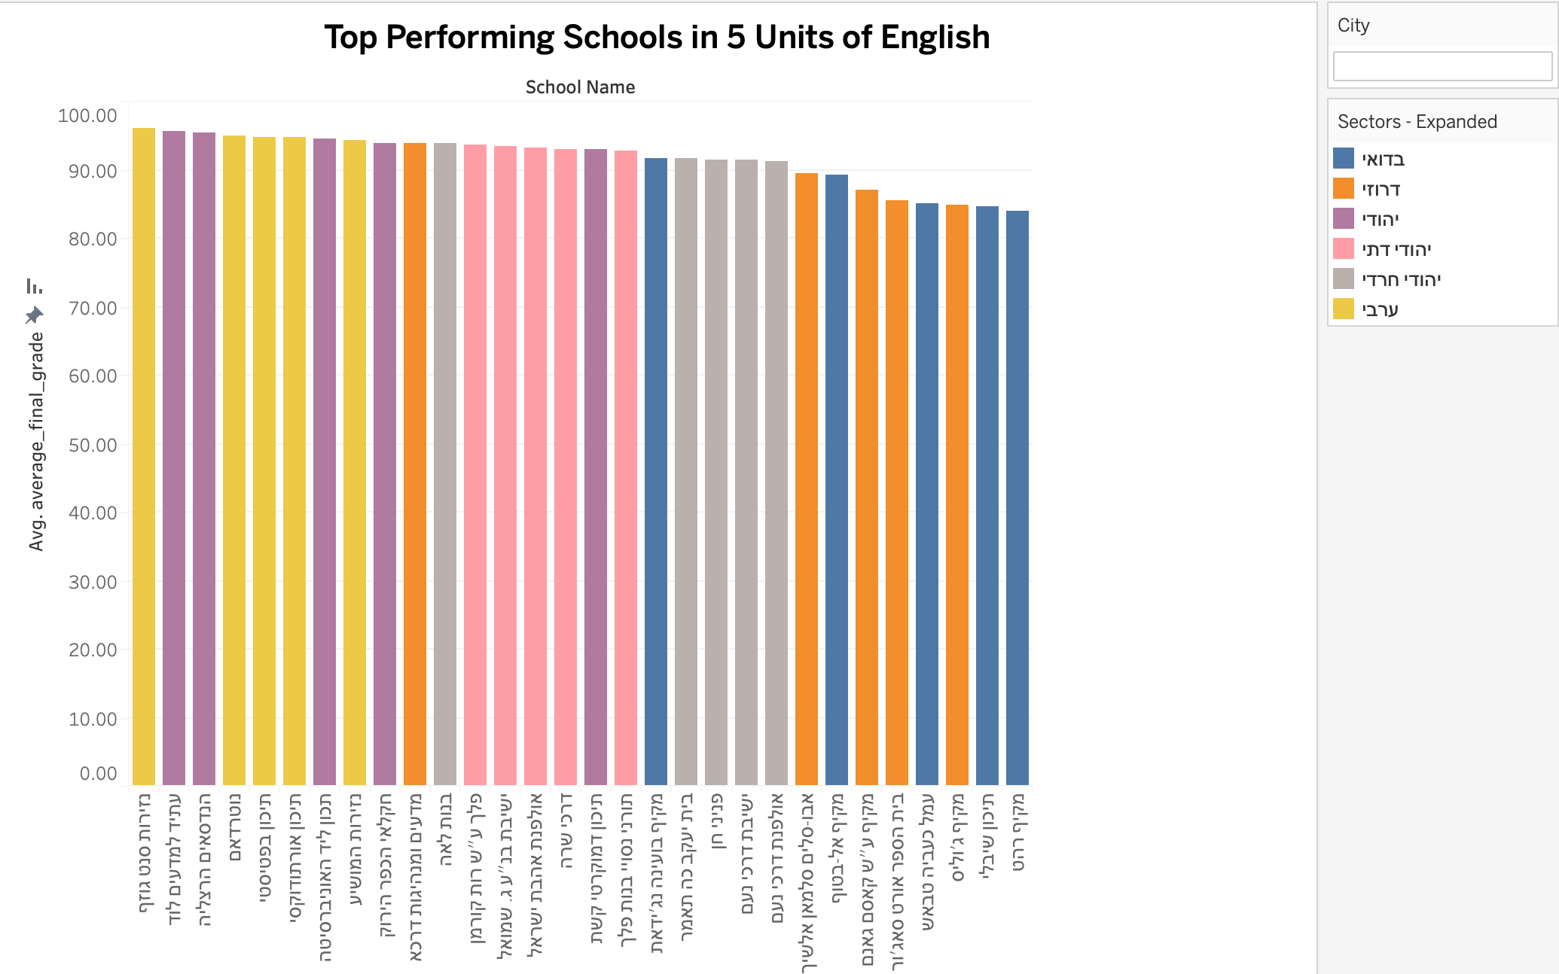

The graph displays top 5 schools with the highest average grades in 5 units of English from each sector.

We can observe that in this graph, Bedouin and Druze sectors are in the bottom of top performing schools, and in the previous graph they had lowest average grade.

We can also observe that schools in Arab sector appeared at the top.